Problems with customized Crystal Reports files after upgrade to beas 9.3 PL 0

- Steps to reproduce the issue

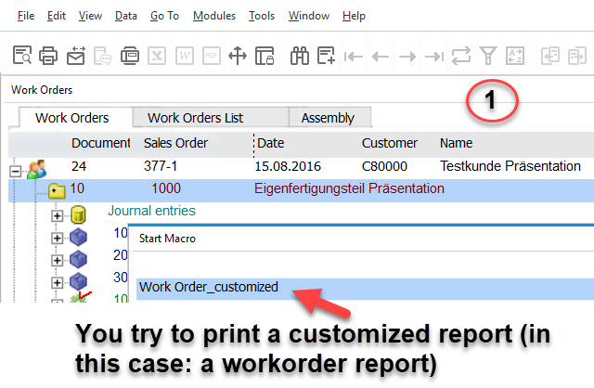

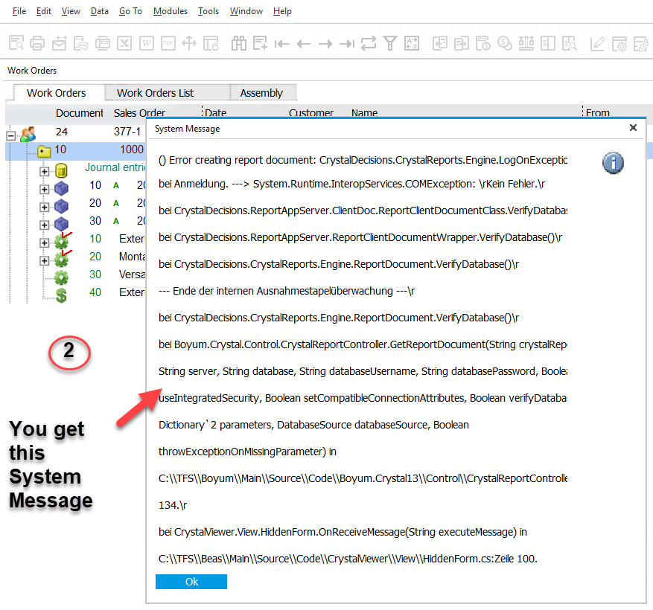

- How to solve this issue

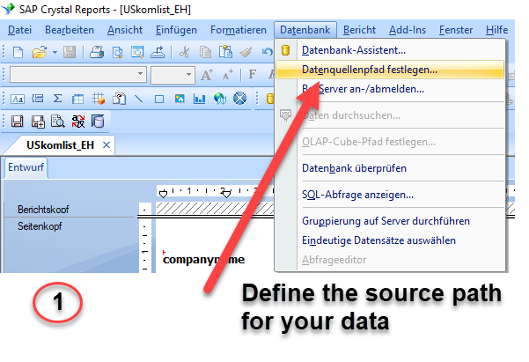

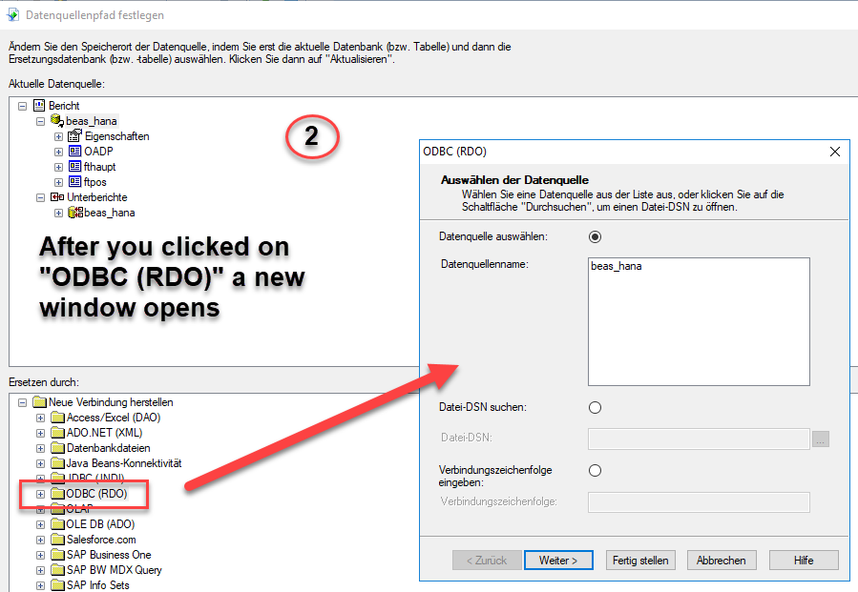

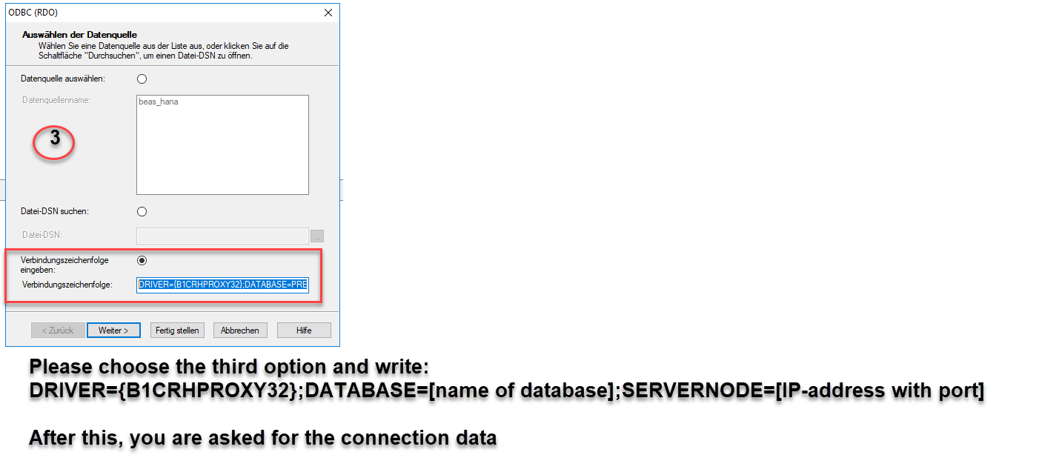

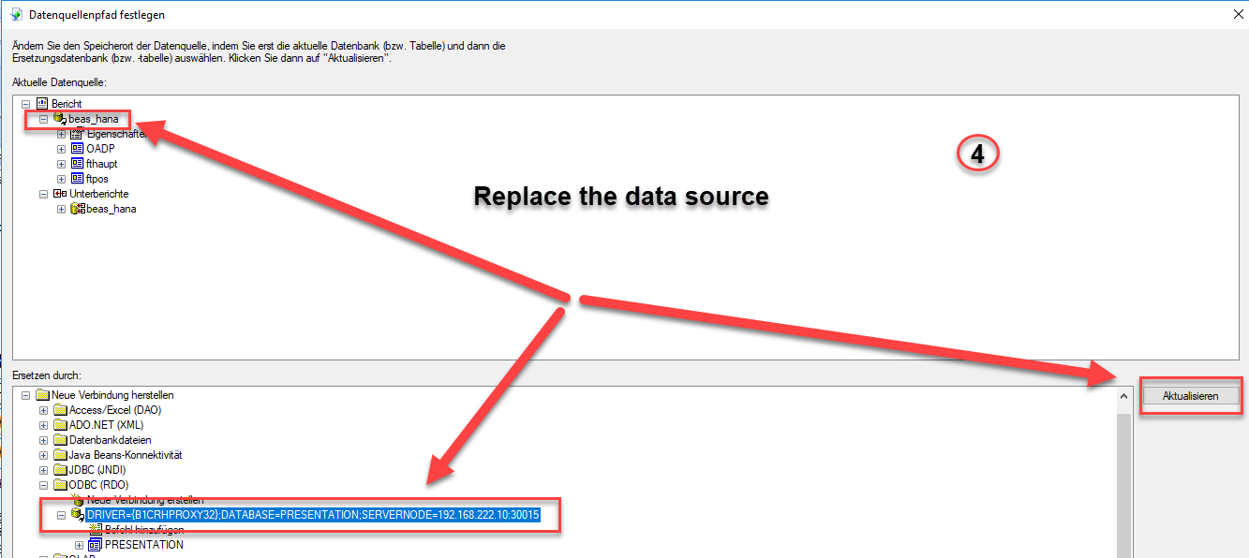

DRIVER={B1CRHPROXY32};DATABASE=TRAINING_1;SERVERNODE=SAPHANAP1:30015

