Explanation of Sample-code
Code simply make a a Form 2 times in Method “Create Sample Form”
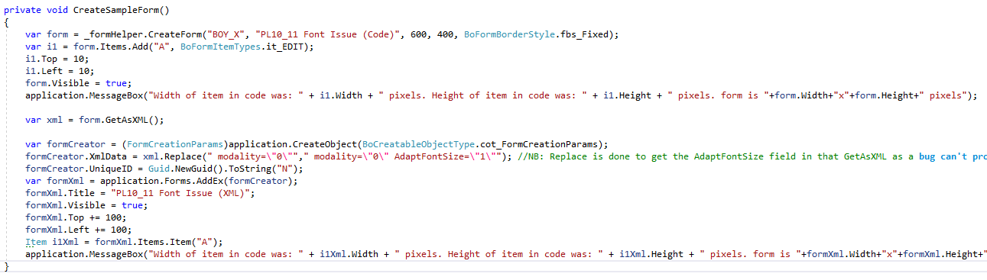
It simple make a form in Code and show it. Takes the Form as XML and show it anew based on the XML.
If you run the Code on SAP 9.3 PL09 with font-size 14 you get following results (as expected)
Code-mode
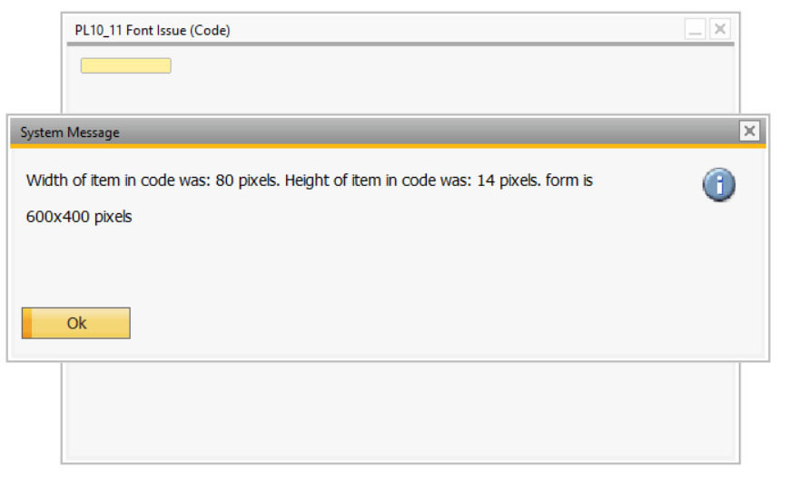
XML-Mode
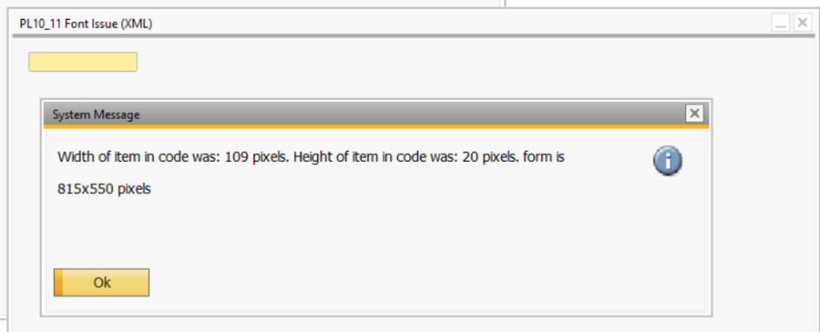

If you run the Code on SAP 9.3 PL10 or 11 with font-size 10 you get following results (Expected)
Code-mode
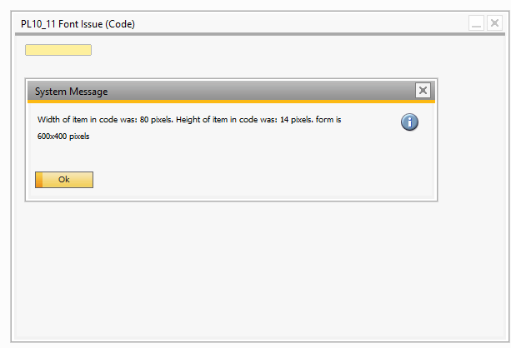
XML Mode
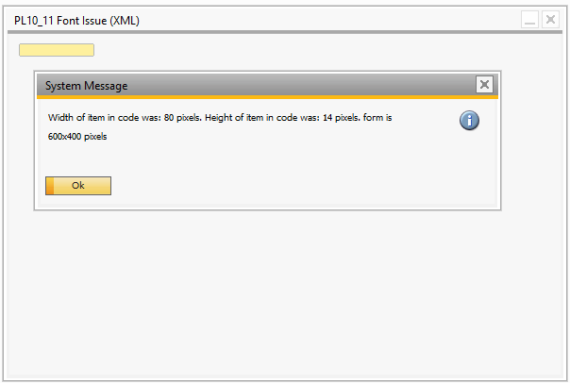

If you run the Code on SAP 9.3 PL10 or 11 with font-size 14 you get following results (issue explained below)
Code-mode
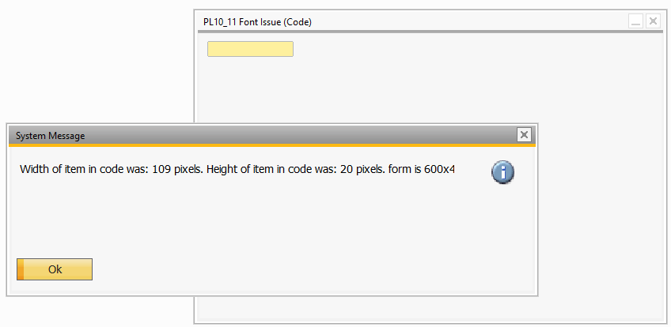
(This wrongly adjust edit-text width and height (SDK did not do this in PL09). Even if in your opinion this is right, I will claim that it is then wrong that it do not adjust the Form Width and Height to adjust for this bigger GUI elements).
XML-mode
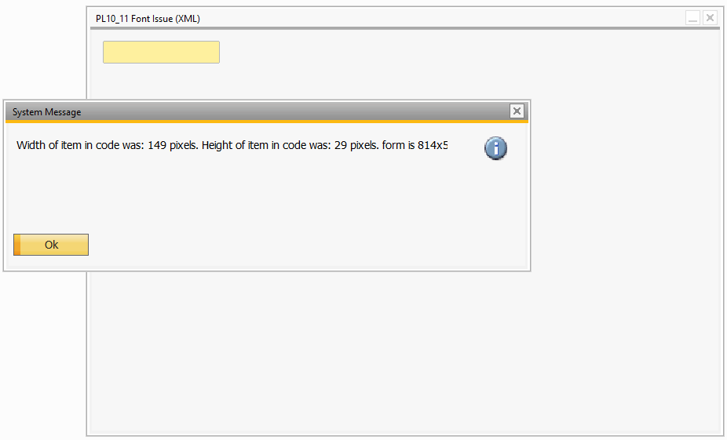
If the XML from the code mode is used to generate a Form it incorrectly also apply font-size adaption. This result in the fiend not fitting Font Size 14… Another bug noticed during testing of this is that you now in XML Mode Adapt Font-size even if the AdaptFontSize XML attribute is not existing in the XML… That is wrong. It should not do it unless the attribute is there (else the purpose of the attribute is meaningless)
