Changes compared to the ”normal” documents

Header SQL:
Normal:
/* DECLARATIONS - BEGIN (DO NOT CHANGE) */
DECLARE @docEntry AS INT
DECLARE @objectId AS NVARCHAR(20)
SET @objectId = {?ObjectId@}
SET @docEntry = {?DocKey@}
Should be changed to:
/* DECLARATIONS - BEGIN (DO NOT CHANGE) */
DECLARE @CardCode AS NVARCHAR(15)
SET @CardCode = '{?CardCode}'
DECLARE @objectId AS NVARCHAR(20)
SET @objectId = {?ObjectId@}
Normal:
LEFT JOIN OCTG T9 ON T0.GroupNum = T9.GroupNum
WHERE T0.DocEntry = '+@docEntry)
/* SELECTION - END
Should be changed to:
LEFT JOIN OCTG T9 ON T0.GroupNum = T9.GroupNum
WHERE T0.DocEntry IN (SELECT TS0.DocEntry FROM OINV TS0 WHERE TS0.DOCSTATUS = ''O'' AND TS0.DOCDUEDATE < GETDATE() + 2 AND TS0.PAIDSUM = 0 AND TS0.U_BOY_DDRS = ''N'' AND TS0.CardCode = '''+@CardCode+''')')
/* SELECTION - END */
Normal:
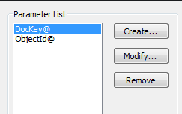
Should be changed to:
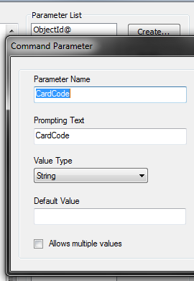

Line SQL:
Normal:
/* DECLARATIONS - BEGIN (DO NOT CHANGE) */
DECLARE @docEntry AS INT
DECLARE @objectId AS NVARCHAR(20)
SET @objectId = {?ObjectId@}
SET @docEntry = {?DocKey@}
Should be changed to:
/* DECLARATIONS - BEGIN (DO NOT CHANGE) */
DECLARE @docEntry AS NVARCHAR(254)
SET @docEntry = '(SELECT TS0.DocEntry FROM OINV TS0 WHERE TS0.DOCSTATUS = ''O'' AND TS0.DOCDUEDATE < GETDATE() + 2 AND TS0.PAIDSUM = 0 AND TS0.U_BOY_DDRS = ''N'' AND TS0.CardCode = '''+'{?CardCode}'+''')'

DECLARE @objectId AS NVARCHAR(20)
SET @objectId = {?ObjectId@}
Normal:
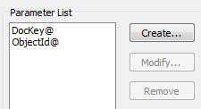
Should be changed to:
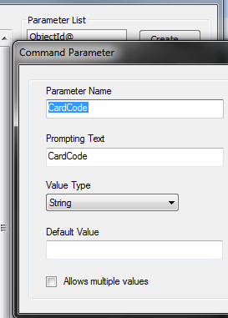

Report:
You will need to create a group on the Header.DocEntry:
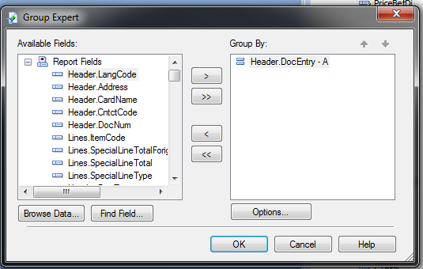
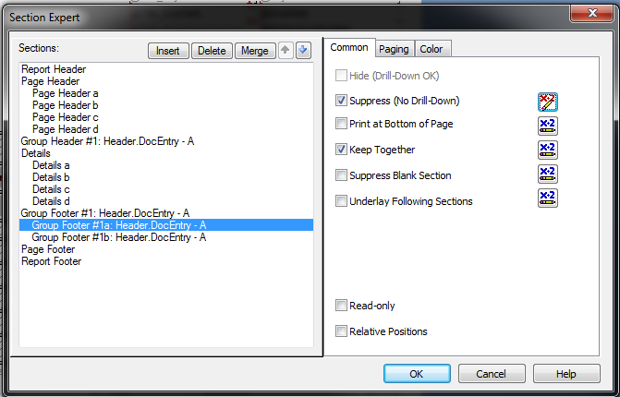

This should be inserted as a group:
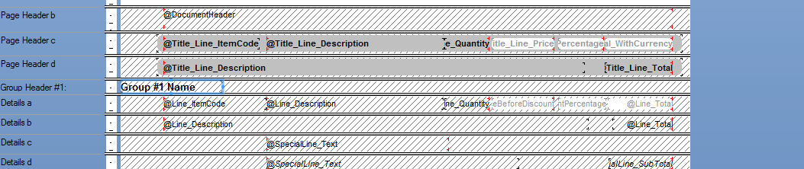
You also need to setup paging for group foot.
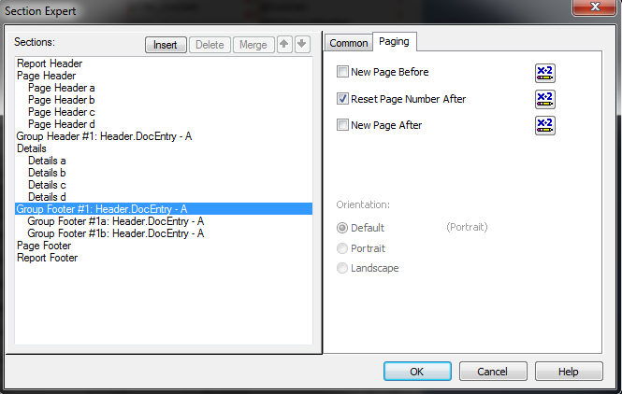
You will need to move the Report Footer b content into the group footer 1b.
Normal:
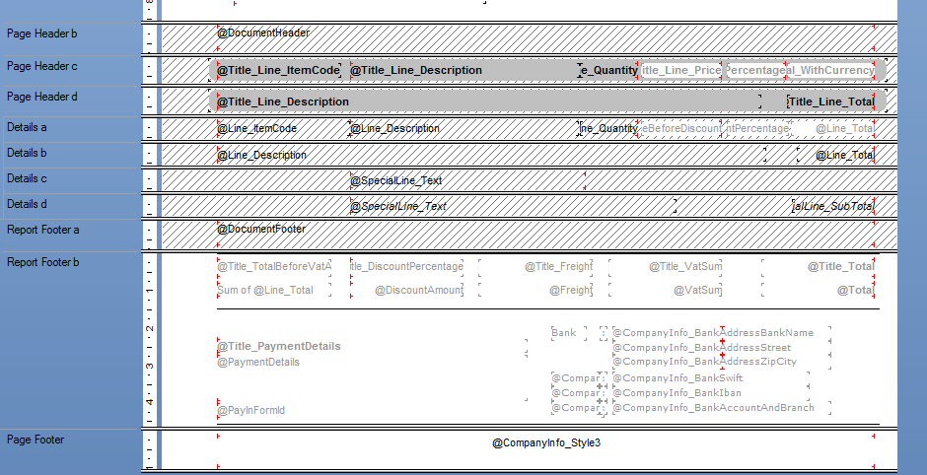

After change
