How to mark an Invoice as exported from UF – File Exporter – Without using Update query statement
The most common way in Universal Function – File Exporter (UFFE) to mark something as printed is with a SQL Query.. Like this (Sample assume UDF is called U_EXPORTED but fit to your own UDF):
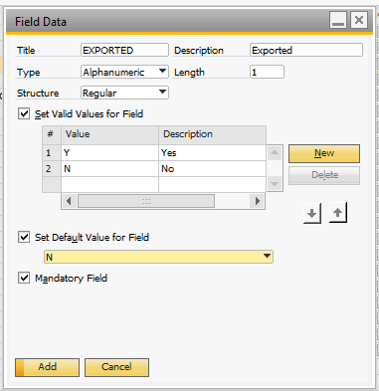
In the UFFE you update it like this with SQL:
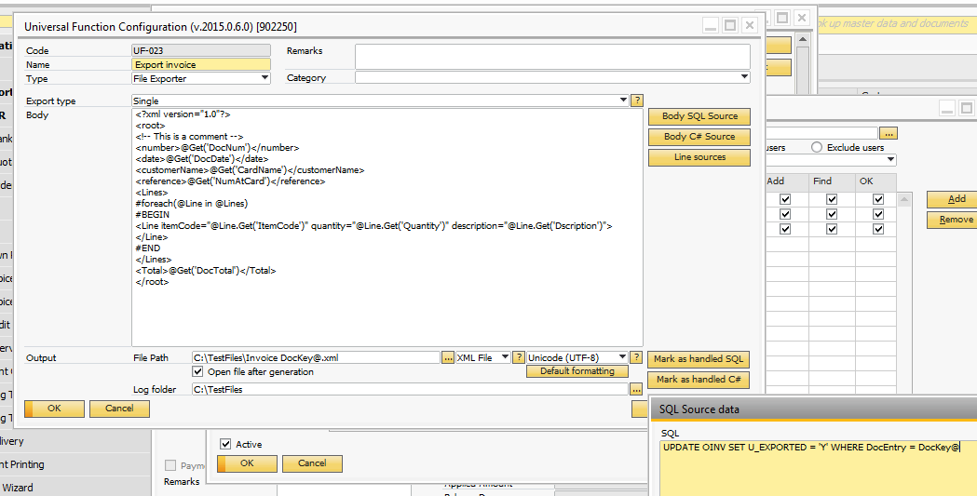
If you for some reason do not wish to use Update SQL to do this (Technically legal as it is UDF but a “gray” area) you can instead do it with C# and the SDK. The drawback of this approach is that it is slower but follow all official rules of the SDK
- You need to do the following steps:
  - Press the Mark as handled C# button. The following window will appear
  - 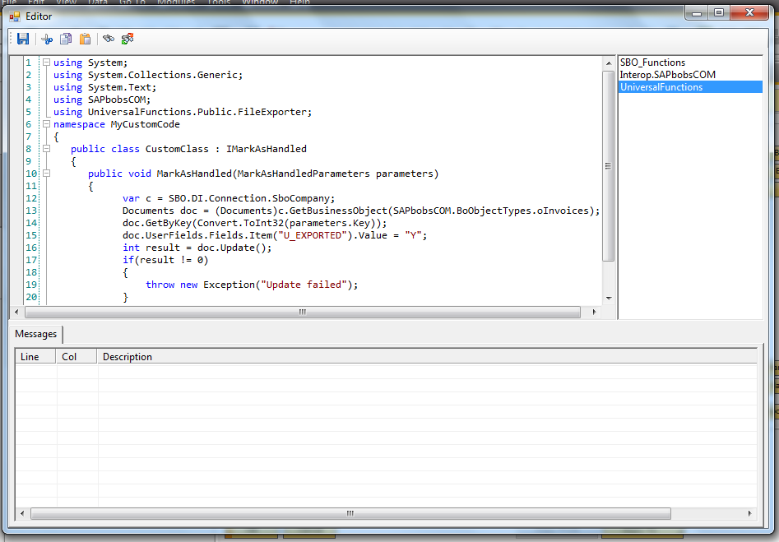
  - On the right hand sidebar right click and choose “Add Assembly”
  - 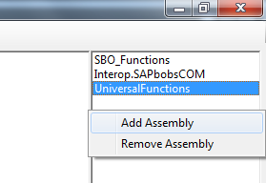
    - Choose file: "C:\Program Files (x86)\SAP\SAP Business One\AddOns\BOY\B1 Usability Package\SBO_Functions.dll" and press OK
    - Repeat above 2 more times for the following two files: "C:\Program Files (x86)\SAP\SAP Business One\AddOns\BOY\B1 Usability Package\Interop.SAPbobsCOM.dll" and "C:\Program Files (x86)\SAP\SAP Business One\AddOns\BOY\B1 Usability Package\UniversalFunctions.dll"
    - NB: The above paths assume you run 32 bit version of SAP .. If you run 64 bit the fiels are located in C:\Program Files\... instead of C:\Program Files (x86)\
  - Now in the code-window remove all existing code and enter the below code (NB – remember to change the name of the UDF if your are not called U_EXPORTED) and close the windows to save it, say say to save it and update the UFFE config:

using System;
using System.Collections.Generic;
using System.Text;
using SAPbobsCOM;
using UniversalFunctions.Public.FileExporter;
namespace MyCustomCode
{
public class CustomClass : IMarkAsHandled
{
public void MarkAsHandled(MarkAsHandledParameters parameters)
{
var c = SBO.DI.Connection.SboCompany;
Documents doc = (Documents)c.GetBusinessObject(SAPbobsCOM.BoObjectTypes.oInvoices);
doc.GetByKey(Convert.ToInt32(parameters.Key));
doc.UserFields.Fields.Item("U_EXPORTED").Value = "Y";
int result = doc.Update();
if(result != 0)
{
throw new Exception("Update failed");
}
}
}
}

