Customization Request
We reserve all rights in this document and in the information contained therein. Reproduction, use, or disclosure to third parties without express authority is strictly forbidden.

Contents
1. Status of the Customization Request 1
2. Customization Request Details 2
3. Confirmation of Scope and Cost Estimation 3
4. Final Estimation after Technical Analysis 4
5. Approval and Signature 5
6. Customization Request Delivery 6
6.1. User Acceptance Test Scripts 6
7. Appendix 1: Commercial Conditions 8
8. Appendix 2: Software Delivery Receipt 9
9. Appendix 3: The Customization Request Process 9

Status of the Customization Request
THIS SECTION MUST BE FILLED IN BY BOYUM IT SOLUTIONS

☐ Preliminary requirement analysis – awaiting information by Partner
☐ Scope and cost estimation approved – awaiting quotation by Boyum IT Solutions
☐ Quotation delivered – awaiting signature and Purchase Order by Partner
☐ Signature and Purchase Order completed – awaiting development and testing by Boyum IT Solutions
☐ Development and testing completed – awaiting delivery of customization and invoicing by Boyum IT Solutions
☐ Customization delivered and invoiced

Customization Request Details
THIS SECTION MUST BE FILLED IN BY THE PARTNER

Information fields marked with * are mandatory to fill in.

GENERAL INFORMATION
Customer name* |  | Partner Name*
Contact person* |  | Backup contact person*
Zendesk ticket* |  | Document Revision
Submission date* | Pick date | Request completion date* | Pick date
Request title

PRODUCT AND ENVIRONMENT INFORMATION
Product Name*
☐ Beas Manufacturing | ☐ Produmex WMS
☐ New Beas web-apps development | ☐ Produmex Scan
☐ Other: enter product name
Product version*
SAP Business One installation number*
SAP Business One version
Database version*
Operating System*

REQUEST TYPE*
☐ Change in Existing process | ☐ Additional functionality development
☐ New Report Request | ☐ Lack of functionality in core product

CUSTOMIZATION REQUEST PRIORITY*
Check only one box to indicate the priority of the request based on the descriptions provided.
High: Critical for Go Live - Normal: Important After Go Live - Low: Not Time Critical
☐ High*: Go Live date =______ | ☐ Normal | ☐ Low
*Go live date is mandatory for high priority requests. If a go live is not impacted by the customization request, priority must be either Normal or Low or your ticket will be downgraded.
PROPOSED REQUEST IMPACT
Enter a description of the problem that is causing the need for change, benefits of making the proposed change, and risks / impacts of not making the change. If you classified a ticket in High, this is a mandatory field.
Modules affected |  | Sub-modules affected

PROPOSED CHANGE DESCRIPTION*
Please make sure to provide a detailed requirement documentation outlining the following:

- WHAT the system should do.
- HOW the system should do it.

Please provide all relevant information related to the process you want to perform in the system along with all the technical information required. Please provide:

- UML diagrams of the business process applied to the Boyum IT software you wish to customize.
- Screenshots / mock-ups of the software functionalities you require (if applicable).
- All technical details related to new database fields and/or tables you wish to create within SAP Business One relevant to this customization.
- The step-by-step interaction you want the end user to have on the customized functionality.
- Any additional information / documentation that is relevant to the customization request.

PLEASE NOTE: any feature or functionality not explicitly mentioned in this section of the document, will be considered OUT OF SCOPE of the present change request.

Type your content here

CURRENT WORKAROUND
If applicable, enter a description of steps that have been or could be taken to address the problem without implementing the requested change.

Type your content here

POTENTIAL COST CONSIDERATIONS
If applicable, enter the potential financial impact to the customer.

Type your content here

ALREADY EXISTING CUSTOMIZATIONS WHICH MAY IMPACT THE CURRENT CUSTOMIZATION REQUEST
Enter any potential customization on your system that may have an influence on the current customization process. If in doubt, please attach the customized files related to the current customized module.

Type your content here

Confirmation of Scope and Cost Estimation
THIS SECTION MUST BE FILLED IN BY BOYUM IT SOLUTIONS

Customer approval is mandatory must be in written (by e-mail) before Boyum IT Solutions can proceed with technical analysis and final estimation.

Based on the description of the customization request in section 1 “Customization Request Analysis”, we have pre-estimated an effort for the customization request. Our estimation of this assignment sums up to a total of:

Type your content here hours.

This pre-estimation is based on a functional scope and calculation carried out by the Boyum IT Partner Success Unit.
It is mandatory to approve this pre-estimation before we can continue the process and develop a quotation on the accurate scope and price.

NOTE! This estimation is indicative only. The final scope and price is delivered in a binding quotation after we have done the Customization Request Analysis (technical analysis by our Product Development department) and added any consultancy hours necessary to complete the project.

Final Estimation after Technical Analysis
THIS SECTION MUST BE FILLED IN BY BOYUM IT SOLUTIONS

Time and Price*
Boyum IT provides a due date and an estimated effort in hours for the following tasks
Plan and refine | Pick date | Number of hours
Coding | Pick date | Number of hours
Testing | Pick date | Number of hours
Delivering customization package | Pick date | Number of hours
Total hours |  | 0,00
Total price |  | 0,00

This Customization Request will be planned immediately after we have received a signed copy and proof of purchase, according to the delivery date estimation.

Approval and Signature
Recognized and accepted:

☐ Confirmation of scope and cost estimation
☐ Final estimation after Technical Analysis

For Company name  Partner reference |  | Boyum reference
Signature |  | Signature
Name: |  | Name:
Title: |  | Title: Customization Request consultant
Date: |  | Date:

Customization Request Delivery
THIS SECTION IS FOR INTERNAL USE FOR BOYUM IT SOLUTIONS

Customization Request Decision  (Internal Use Only) | ☐ Rework ☐ Not Accepted ☐ Withdrawn  ☐ Approved ☐ Approved with limitations
Limitations / Risks for implementing this change
Reviewer Name
Date | Pick date

DOCUMENTATION OF THE ADDED CODE

Type your content here

PROJECT NUMBER related to the Customization Request Template (for internal use only):

Type your content here

User Acceptance Test Scripts
USER ACCEPTANCE TEST SCRIPTS*
User Acceptance Testing is a mandatory step for the end-customer, to identify any potential errors of the customization by running all appropriate checks and tests in the customer environment. UAT is the last phase of the customization request. UAT must occur before the customization can be rolled out to the market. During UAT, you must ensure that the customization fulfills the required tasks in real-world scenarios and that the customization is tested from a user’s perspective.

You must fill in all the cases that cover specific usage scenarios of the customization. Typically, this will be a set of actions which the user can carry out in order to verify that the customization works as intended according to requirements. The tests must be run, and the results recorded – were the tests successful or did they show defects? Any defects / bugs identified in the UAT phase must be corrected and re-tested.

PLEASE NOTE! The User Acceptance Test is mandatory and must be completed by the partner once the customization has been delivered. The Customization Warranty Period starts on the day of the delivery of the customization and is not pending on confirmation of delivery of the customization.

Product Area (Window)*
Scenario*
Test step*
Expected result*
Actual result*
Tested by*
Test date* | Pick date
Fail / Pass*
Boyum IT - Industry leading solution provider
Boyum IT is the largest and best-known global software solution partner for SAP Business One. We are a member
of the SAP Partner Solution Council and have been honored to have received more than 20 SAP awards. Among
these are the SAP Global Solution of the Year Award and People’s Choice Award, which we received the last 3
years in a row. We have the largest partner and customer ecosystems, with a presence in more than 100 countries and over 8,000 customers and 185,000 users.

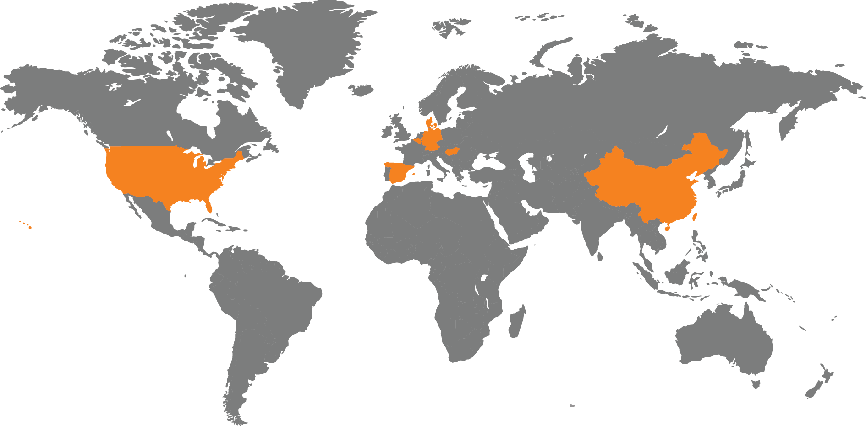

Boyum IT Solutions A/S Headquarters (Denmark)

 | + 45 87 32 90 00 |  |  | facebook.com/boyumit |  |  | Boyum IT Solutions
 | sales@boyum-it.com |  |  | youtube.com/user/boyumit |  |  | Sintrupvej 71b, 1th
 | boyum-solutions.com |  |  | twitter.com/boyumit |  |  | DK - 8220 Brabrand

Appendix 1: Commercial Conditions
Pricing

Prices for customizations always refer to Boyum IT Solutions’ standard service prices, which you can find here.

The final price of this customization can be found in Section 4 “Final Estimation after Technical Analysis”.

Period of validity quotation

7 business days from the date of the quotation.

If the quotation has not been signed and a Purchase Order placed within 7 business days, the delivery date and price of the customization will be re-calculated.

Terms of payment

Our invoices are payable according to the partner’s payment terms in the valid Reseller Agreement.

* For projects below 8 hours, we invoice the full amount at order. For projects above 8 hours, we invoice 50% at order and 50% at delivery.

For delivery and performance our general terms and conditions apply. They can be downloaded from our website.

Deliverables

This Customization Request includes the fixed cost of the following Boyum IT Solutions services:

- Problem Analysis
- Technical description
- Software Development
- Internal Tests
- Delivery of the software
- Completion of associated documentation

Responsibilities of the Customer

The customer is responsible for:

- Installing the software on its hardware system(s)
- Installation and thorough testing of the delivered software in its test environment
- Any software bugs should be reported to Boyum IT Solutions. A software bug is an error regarding the technical description that can be demonstrated and can be reproducibly prepared.
- Commissioning of the software on his production system

The above “Responsibilities of the Customer” can sometimes be performed or assisted by the partner.

Appendix 2: Software Delivery Receipt
The Software Delivery Receipt guarantees that the software of your customization request has been delivered. The software delivery will always happen after successful internal testing by Boyum IT Solutions to ensure that the specifications and requirements defined in the Customization Request Template have been fulfilled.

Warranty Period

Upon delivery of the customization, our 90-day warranty period starts. During the warranty period, Boyum IT Solutions offers free support for any bug identified in relation to the customization.

The 90-day warranty period is not pending on customer confirmation of the delivery of the customization.

To receive free support, the environment in which the software has been installed must remain as specified in the Customization Request Template. If the environment is in any way changed, any support for the customization will be classified as Premium Service and will be billed accordingly on a case-by-case basis.

Once the 90-day warranty period is over, any support for the customization will be classified as Premium Service and will be billed accordingly on a case-by-case basis.

Appendix 3: The Customization Request Process
The complete process can be found on the Boyum Helpdesk.

